Dear {first/preferred name},   
  
Hello from the Aspirations 2030 Study Team! Thank you for sharing your aspirations for 2030 with us last {month_of_session}. Over the past year, we spoke with more than **5,000** **women** across the Western Visayas. We were so inspired by your vision for 2030 and the visions of so many other Visayan women 🌈🌟. See more below!   
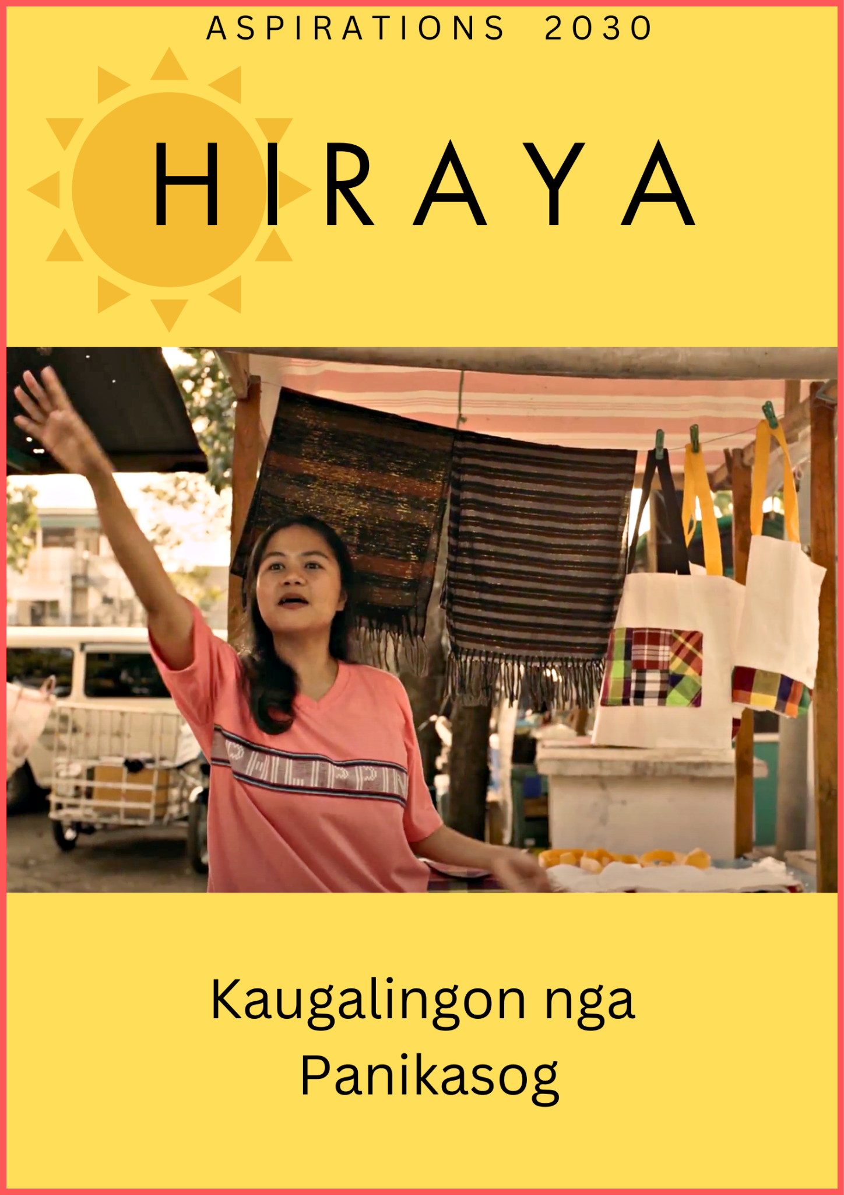

| **What did you say?**  Just like Hiraya, you imagined your future and envisioned ways to pursue your goal of **<goal>**. We hope that drawing on your values of **<value_1, value_2, and value_3>** and your strengths of **your <2 top strengths>** will help you along the way. You can always look at your folder to remind yourself of the activities [T1: you did]/[T2/T3: we did together]. |
| --- |

| ]T3:] **What did people say in the barangay event?**  After watching the Hiraya film and imagining your barangay’s future together, your barangay told us that they value <**value_1, value_2,** and **value_3>**.  Across the Western Visayas, community members said that they want to:  “Contribute to their barangays by employing others”  “Teach others in their barangay about new livelihoods”  “Guide children in reaching their dreams”  “Be role models for the children of the barangay” |
| --- |

| **What did women from your barangay and other barangays say?**  **Values**: [T1: The most popular values that women chose  were **perseverance** and **self-reliance**.] [T2/T3: Like you, many other women said that their most important value was [**respect of others/helpfulness/perseverance**].    **Goals: 9** out of 10 women had goals related to **improving**  **their livelihoods or savings**. The second most popular goal  women had was to **further their education and skills.** |
| --- |

| **What did participants say they found most valuable in the session?**    ***Visualizing the future*:** Many women have continued to visualize their futures, some even doing it with daily prayers. They said it makes them feel **more hopeful and lighter**. When you close your eyes and visualize your future in 2030, what is one positive thing you see?    ***Vision map* :** The vision map–where you draw or write your main goal in the center and steps to achieve it in surrounding circles–**helped women see a path to the future they imagined.** Because so many women found it useful, we’ve included an extra map for you to redraw your goal or even use it for a new goal.    [T2/T3: ***Tree***: Women imagined supporters from their family and community as branches on their tree. Who are the people who give you strength and support to reach your goals these days? |
| --- |

| **What advice did women give [T1: to their future selves / T2-3: to the next generation of women]?** |
| --- |

**Thank you for sharing your heart and mind!** We hope that the thousands of Visayan women who read this will be inspired by your [T1: strength and hopeful visions / T2-T3: strength, solidarity, and hopeful visions]. We look forward to following up in the future and hearing about your next chapter. We wish you [T2/3: and your barangay] [T1: peace / T2-3: harmony] and prosperity now and in the years to come!

**- The Aspirations 2030 Study Team**